Country Information
1. Country identification and size of population | AT BE BG CY CZ DE DK EE EL ES  FI FR HU IE IS IT LI LT LU LV  MT NL NO PL PT RO SE SI SK UK  Population size: 10 000 000
Agency Information
2. Agency title and contact details | Name: Inst. for State Control of Vet. Biologicals and Medicam  Address: Hudcova 56a  Phone: 420541518211 Fax: 420541210026  E-mail: uskvbl@uskvbl.cz
3. Head of Agency contact details | Please fill CV below on page 4.
4. Regular Representative at HMA Meetings | Please fill CV below on page 5 (if needed).
5. Contact Person for HMA Issues | Name: Prof.D.V.M. Alfred Hera, PhD  Phone: 541518201 Mobile: 602487743 Fax: 541210026  E-mail: hera@uskvbl.cz
6. Type of agency / entity | Independent body  General Directorate. Please specify which Ministry: M. of Agriculture  Other, please specify:
7. Date of establishment of the Agency | Date: 1. 1. 1968  Please provide any complementary information you may consider relevant:
8. Areas of competence

Human medicinal products
Veterinary medicinal products
Medical Devices
Cosmetics
Others
(please specify): vet.preparations

Information updated on:

9. Responsibilities | Human |  |  |  |  |  | Veterinary |  |  |  | Medical Devices | Cosmetics
9. Responsibilities | Pharmacological (incl. chemical and biological/biotech) | Immunological | Homeopathic | Blood products | Herbals | Advanced therapies | Pharmacological | Immunological | Homeopathic | Blood products | Medical Devices | Cosmetics
Authorisation / registration
Clinical Trials / Investigation
Pharmacovigilance / Vigilance / Surveillance
Inspection /
Compliance
Quality Control
Batch release
Pricing
Health Technology Assessment (HTA) / Reimbursement
Regulatory and scientific advice
Information to patients
Information to healthcare professionals
Advertising control
Residues monitoring
Designation and supervision of Notified Bodies
Other (please specify) | veterinary (no medicinal) products, i.e.border line products and in vitro diagnostics etc.

Information updated on:

Human Resources
10. Total Number of Employees:92 Full Time: 78 Part-Time: 14 Full-Time equivalence: 84
Outsourced activities:
11. Identification of Internal Experts | Total Number:
11. Identification of Internal Experts | Areas of Expertise / Number of Experts
11. Identification of Internal Experts | Quality Pre-clinical Clinical  Species Inspections Ecotoxicity  Residues Pharmacovigilance  Others Please specify which:
12. Identification of External Experts (including outsource) | Total Number:
12. Identification of External Experts (including outsource) | Areas of Expertise / Number of Experts
12. Identification of External Experts (including outsource) | Quality Pre-clinical Clinical  Species Inspections Ecotoxicity  Residues Pharmacovigilance  Others Please specify which:
Funding
13. Funding | Budget (state budget) % of budget: 86  Fees (Industry fees/taxes) % of budget: 14  Other Please specify which:
14. Total of expenses (Euros) | 2006: | 2007: 2800000 Eu
15. Total of revenues (Euros) | 2006: | 2007: 400000 Eur
Activities
16. Mission of the organisation (max. 200 characters):
authorisation of VMPs, Inspection activities, Pharmacovigilans, Laboratory Control of VMPs, Residues Monitoring

17. Complementary information | In the case you may consider it useful, please provide complementary information which could clarify any of the issues mentioned above or any specific understanding of your agency on any specific issue or activity (max 200 characters):

Name of the person responsible for completing this questionnaire: |  | Information updated on:
Head of Agency
Curriculum Vitae

Name of Head of Agency: |  |  |  | 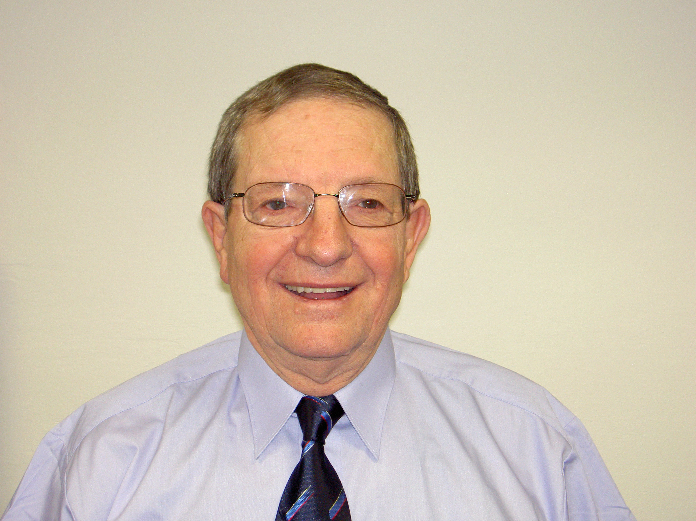
Alfred Hera
Academic / Professional title: |  | Prof. D.V.M. PhD
Name of Agency: | Inst.for State Control of Vet.Biol.+Med.

Country:
AT BE BG CY CZ DE DK EE EL ES FI FR HU IE IS
IT LI LT LU LV MT NL NO PL PT RO SE SI SK UK

Contact details:
Address: Hudcova 56a, Brno, 621 00
Telephone: 541518201 Mobile: 602487743 Fax: 541210026
E-mail: hera@uskvbl.cz

Years within the agency: | 41

Education (Institution, area/field pf expertise, country, date) (max. 300 characters)::
Veterinary University
Dr.Vet.Med. University
Ph.D.Thesis
Habilitation Thesis University - Assoc.Prof.

Professional experience
(Institution/company, country, position, date. Please provide only information on your current and last 2 jobs). (max. 400 characters):
State Veterinary Administration - veterinary surgeon 1963 - 1965
Institute for State Control of Veterinary Biologicals and Medicaments 1965 - till now

Specialisation
Please provide details (max. 300 characters):
Basic and clinical pharmacology
Regulatory affairs
Veterinary Medicinal Premixes and Medicated Feed
Residues of Veterinary Medicinal Substances

Member of any HMA Working Group: | no | Information updated on:  05/ 2008

