Country Information
1. Country identification and size of population | AT BE BG CY CZ DE DK EE EL ES  FI FR HU IE IS IT LI LT LU LV  MT NL NO PL PT RO SE SI SK UK  Population size: 1 340 000
Agency Information
2. Agency title and contact details | Name: State Agency of Medicines  Address: 1 Nooruse Street 50411 Tartu, Estonia  Phone: 3727374140 Fax: 3727374142  E-mail: info@ravimiamet.ee
3. Head of Agency contact details | Please fill CV below on page 4.
4. Regular Representative at HMA Meetings | Please fill CV below on page 5 (if needed).
5. Contact Person for HMA Issues | Name:Kristin Raudsepp  Phone: 3727374140 Mobile: 3725108455 Fax: 3727374142  E-mail: Kristin.Raudsepp@ravimiamet.ee
6. Type of agency / entity | Independent body  General Directorate. Please specify which Ministry: of Social Affairs  Other, please specify:
7. Date of establishment of the Agency | Date: 12.04.1991  Please provide any complementary information you may consider relevant:
8. Areas of competence

Human medicinal products
Veterinary medicinal products
Medical Devices
Cosmetics
Others
(please specify):

Information updated on:
March 2012
9. Responsibilities | Human |  |  |  |  |  | Veterinary |  |  |  | Medical Devices | Cosmetics
9. Responsibilities | Pharmacological (incl. chemical and biological/biotech) | Immunological | Homeopathic | Blood products | Herbals | Advanced therapies | Pharmacological | Immunological | Homeopathic | Blood products | Medical Devices | Cosmetics
Authorisation / registration
Clinical Trials / Investigation
Pharmacovigilance / Vigilance / Surveillance
Inspection /
Compliance
Quality Control
Batch release
Pricing
Health Technology Assessment (HTA) / Reimbursement
Regulatory and scientific advice
Information to patients
Information to healthcare professionals
Advertising control
Residues monitoring
Designation and supervision of Notified Bodies
Other (please specify)

Information updated on:
March 2012
Human Resources
10. Total Number of Employees: 81 Full Time: 71 Part-Time: 10 Full-Time equivalence:
Outsourced activities:several clinical expertises
11. Identification of Internal Experts | Total Number: 40
11. Identification of Internal Experts | Areas of Expertise / Number of Experts
11. Identification of Internal Experts | Quality 11 Pre-clinical 1 Clinical 6  Species 2 Inspections 6 Ecotoxicity  Residues 1 Pharmacovigilance 5  Others Please specify which:
12. Identification of External Experts (including outsource) | Total Number:
12. Identification of External Experts (including outsource) | Areas of Expertise / Number of Experts
12. Identification of External Experts (including outsource) | Quality 2 Pre-clinical 2 Clinical 20  Species 2 Inspections 1 Ecotoxicity 1  Residues 2 Pharmacovigilance  Others Please specify which:
Funding
13. Funding | Budget (state budget) % of budget: 10  Fees (Industry fees/taxes) % of budget: 90  Other Please specify which:
14. Total of expenses (Euros) | 2010: 2.3 millio | 2011: 2.6 millio
15. Total of revenues (Euros)
Activities
16. Mission of the organisation (max. 200 characters):
State Agency of Medicines is a governmental body under the Ministry of Social Affairs. Its main responsibility is the protection and promotion of public and animal health, through the supervision of medicines for human and veterinary use

17. Complementary information | In the case you may consider it useful, please provide complementary information which could clarify any of the issues mentioned above or any specific understanding of your agency on any specific issue or activity (max 200 characters):

Name of the person responsible for completing this questionnaire: | K. Raudsepp | Information updated on:  March 2012
Head of Agency
Curriculum Vitae

Name of Head of Agency: |  |  |  | 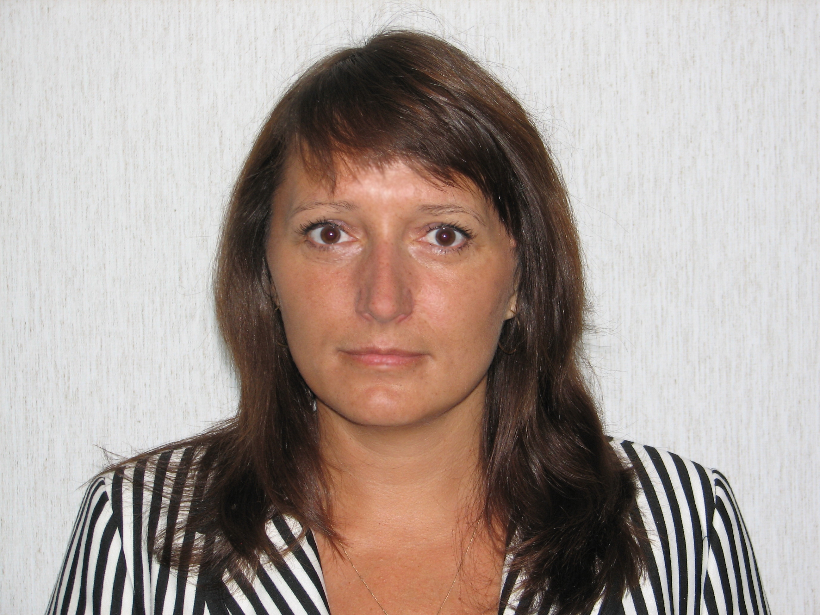
Kristin Raudsepp
Academic / Professional title: |  | Director General
Name of Agency: | State Agency of Medicines

Country:
AT BE BG CY CZ DE DK EE EL ES FI FR HU IE IS
IT LI LT LU LV MT NL NO PL PT RO SE SI SK UK

Contact details:
Address: 1 Nooruse Street 50411 Tartu, Estonia
Telephone: +3727374140 Mobile: +3725108455 Fax: +3727374142
E-mail: Kristin.Raudsepp@ravimiamet.ee

Years within the agency: | 18

Education (Institution, area/field pf expertise, country, date) (max. 300 characters)::
1991-1994 Tartu Maarjamõisa University Clinic physician in internship, graduated as GP

1985-1991 University of Tartu, Estonia
Graduated medicine (MD) from the Faculty of Medicine

Professional experience
(Institution/company, country, position, date. Please provide only information on your current and last 2 jobs). (max. 400 characters):
from 2002 Director General State Agency of Medicines, Estonia

1999-2002 Acting Director General, State Agency of Medicines, Estonia

1997-1999 Head of the Department of Registration, Deputy Director General, State Agency of Medicines, Estonia

Specialisation
Please provide details (max. 300 characters):
Several courses on drug regulatory issues, incl marketing authorisation, drug information, European law. Several trainings in management, incl quality management in public sector; strategic management, motivation, development of staff and co-operation.

Member of any HMA Working Group: | Member of the Heads of Medicines Agencies (HMA);  Estonian representative in the Management Board, the EMA;  Estonian representative in the Pharmaceutical Committee;  Estonian representative in Standing Committee on Medicinal Products for Human Use, European Commission;  Estonian representative in Standing Committee on Medicinal Products for Veterinary Use, European Commission;  - Mentor to the HMA Working Group of Quality Managers | Information updated on:  March 2012

