Country Information
1. Country identification and size of population | AT BE BG CY CZ DE DK EE EL ES  FI FR HU IE IS IT LI LT LU LV  MT NL NO PL PT RO SE SI SK UK  Population size: 63 200 000
Agency Information
2. Agency title and contact details | Name: Afssaps - Agence française de sécurité sanitaire des p  Address: 143-147 Bd Anatole France - 93285 - St Denis cedex  Phone: 33155873000 Fax: +33155873053  E-mail: Dominique.MARANINCHI@afssaps.sante
3. Head of Agency contact details | Please fill CV below on page 4.
4. Regular Representative at HMA Meetings | Please fill CV below on page 5 (if needed).
5. Contact Person for HMA Issues | Name: Miguel BLEY  Phone: 33155873038 Mobile: +33673691767 Fax: +33155873053  E-mail: miguel.bley@afssaps.sante.fr
6. Type of agency / entity | Independent body  General Directorate. Please specify which Ministry:  Other, please specify:
7. Date of establishment of the Agency | Date: 01/03/1998  Please provide any complementary information you may consider relevant:
8. Areas of competence

Human medicinal products
Veterinary medicinal products
Medical Devices
Cosmetics
Others
(please specify): Tatoo products, bioc

Information updated on:
09/05/2008

9. Responsibilities | Human |  |  |  |  |  | Veterinary |  |  |  | Medical Devices | Cosmetics
9. Responsibilities | Pharmacological (incl. chemical and biological/biotech) | Immunological | Homeopathic | Blood products | Herbals | Advanced therapies | Pharmacological | Immunological | Homeopathic | Blood products | Medical Devices | Cosmetics
Authorisation / registration
Clinical Trials / Investigation
Pharmacovigilance / Vigilance / Surveillance
Inspection /
Compliance
Quality Control
Batch release
Pricing
Health Technology Assessment (HTA) / Reimbursement
Regulatory and scientific advice
Information to patients
Information to healthcare professionals
Advertising control
Residues monitoring
Designation and supervision of Notified Bodies
Other (please specify) | PHARMACOPOEIA (NATIONAL PHARMACOPOEIA AUTHORITY)

Information updated on:
09/05/2008

Human Resources
10. Total Number of Employees: 996 Full Time: 811 Part-Time: 185 Full-Time equivalence: 946
Outsourced activities:
11. Identification of Internal Experts | Total Number:
11. Identification of Internal Experts | Areas of Expertise / Number of Experts
11. Identification of Internal Experts | Quality Pre-clinical Clinical  Species Inspections Ecotoxicity  Residues Pharmacovigilance  Others Please specify which:
12. Identification of External Experts (including outsource) | Total Number:
12. Identification of External Experts (including outsource) | Areas of Expertise / Number of Experts
12. Identification of External Experts (including outsource) | Quality Pre-clinical Clinical  Species Inspections Ecotoxicity  Residues Pharmacovigilance  Others Please specify which:
Funding
13. Funding | Budget (state budget) % of budget: 5-15  Fees (Industry fees/taxes) % of budget: 80  Other Please specify which: EMEA/WHO fees 10%
14. Total of expenses (Euros) | 2006: 93.58 M€ | 2007: 104.91 M€
15. Total of revenues (Euros) | 2006: 110.10 M€ | 2007: 97.83 M€
Activities
16. Mission of the organisation (max. 200 characters):
Guarantee the safety, quality and proper use of health products for human use

17. Complementary information | In the case you may consider it useful, please provide complementary information which could clarify any of the issues mentioned above or any specific understanding of your agency on any specific issue or activity (max 200 characters):

Name of the person responsible for completing this questionnaire: | Miguel BLEY | Information updated on:  31/12/2007
Head of Agency
Curriculum Vitae

Name of Head of Agency: |  |  |  | 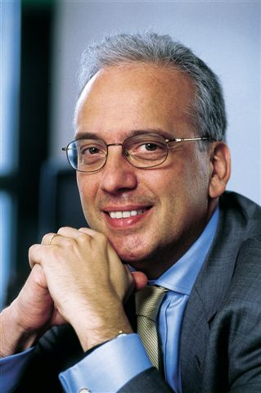
Dominique MARANINCHI
Academic / Professional title:
Name of Agency: | AFSSAPS

Country:
AT BE BG CY CZ DE DK EE EL ES FI FR HU IE IS
IT LI LT LU LV MT NL NO PL PT RO SE SI SK UK

Contact details:
Address: 143-147, Boulevard Anatole France - 93285 - St Denis cedex
Telephone: +33155873014 Mobile: Fax: +33155873012
E-mail: Dominique.MARANINCHI@afssaps.sante.fr

Years within the agency: | 1

Education (Institution, area/field pf expertise, country, date) (max. 300 characters)::

Professional experience
(Institution/company, country, position, date. Please provide only information on your current and last 2 jobs). (max. 400 characters):

Specialisation
Please provide details (max. 300 characters):

Member of any HMA Working Group: |  | Information updated on:  9/05/2008

Regular Representative at HMA Meetings
Curriculum Vitae

Name of the regular representative at HMA meetings: |  |  |  | 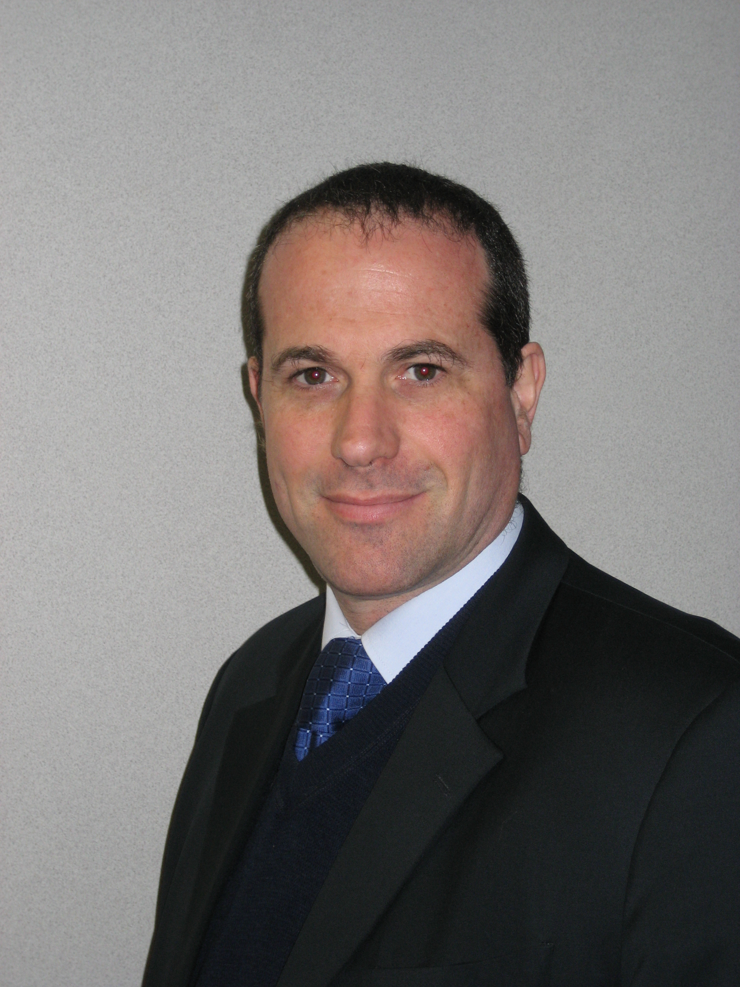
Miguel BLEY
Academic / Professional title: |  | Dr. PhD Biochemistry
Name of Agency: | AFSSAPS

Country:
AT BE BG CY CZ DE DK EE EL ES FI FR HU IE IS
IT LI LT LU LV MT NL NO PL PT RO SE SI SK UK

Contact details:
Address: 143-147, Boulevard Anatole France - 93285 - St Denis cedex
Telephone: +33155873038 Mobile: +33673691767 Fax: +33155873053
E-mail: miguel.bley@afssaps.sante.fr

Years within the agency: | 9

Education (Institution, area/field pf expertise, country, date) (max. 300 characters)::
Buenos Aires University (UBA)
Biochemistry
Argentina
PhD. in 1995

Professional experience
(Institution/company, country, position, date. Please provide only information on your current and last 2 jobs). (max. 400 characters):
From 08/93 to 12/98
Buenos Aires, Argentina
Organisation: Novartis, Argentina
Positions
Oncology Business Unit Manager
Immunology and Transplant Sales Manager
Neurosciences Product Manager
Job descriptions
Business management
Sales management
Product management

From 03/88 to 12/92
Instituto de Biologia y Medicina Experimental
Buenos Aires, Argentina
Research Fellowship
Doctoral Trainee

Specialisation
Please provide details (max. 300 characters):
European Affairs
Normalisation in telematics (electronic submission)

Member of any HMA Working Group: | HMA Telematics Support Group | Information updated on:  09/05/2008

