Country Information
1. Country identification and size of population | AT BE BG CY CZ DE DK EE EL ES  FI FR HU IE IS IT LI LT LU LV  MT NL NO PL PT RO SE SI SK UK  Population size: 65 000 000
Agency Information
2. Agency title and contact details | Name: Anses-ANMV: Jean-Pierre ORAND  Address: BP 90203 35302 FOUGERES  Phone: 33299947871 Fax: 33299947899  E-mail: jean-pierre.orand@anses.fr
3. Head of Agency contact details | Please fill CV below on page 4.
4. Regular Representative at HMA Meetings | Please fill CV below on page 5 (if needed).
5. Contact Person for HMA Issues | Name: Jean-Pierre ORAND  Phone: 33299947871 Mobile: 33613641322 Fax: 33299947899  E-mail: jean-pierre.orand@anses.fr
6. Type of agency / entity | Independent body  General Directorate. Please specify which Ministry:  Other, please specify:
7. Date of establishment of the Agency | Date: 10/02/1994  Please provide any complementary information you may consider relevant:
8. Areas of competence

Human medicinal products
Veterinary medicinal products
Medical Devices
Cosmetics
Others
(please specify):

Information updated on: January 2012

9. Responsibilities | Human |  |  |  |  |  | Veterinary |  |  |  | Medical Devices | Cosmetics
9. Responsibilities | Pharmacological (incl. chemical and biological/biotech) | Immunological | Homeopathic | Blood products | Herbals | Advanced therapies | Pharmacological | Immunological | Homeopathic | Blood products | Medical Devices | Cosmetics
Authorisation / registration
Clinical Trials / Investigation
Pharmacovigilance / Vigilance / Surveillance
Inspection /
Compliance
Quality Control
Batch release
Pricing
Health Technology Assessment (HTA) / Reimbursement
Regulatory and scientific advice
Information to patients
Information to healthcare professionals
Advertising control
Residues monitoring
Designation and supervision of Notified Bodies
Other (please specify)

Information updated on:

Human Resources
10. Total Number of Employees:81 Full Time: 55 Part-Time: 26 Full-Time equivalence: 75,8
Outsourced activities:
11. Identification of Internal Experts | Total Number: 32
11. Identification of Internal Experts | Areas of Expertise / Number of Experts
11. Identification of Internal Experts | Quality 6 Pre-clinical 2 Clinical 2  Species ? Inspections 7 Ecotoxicity 2  Residues 2 Pharmacovigilance 3  Others Please specify which: biologicals:5/ rapporteurs (chemic VMP): 3
12. Identification of External Experts (including outsource) | Total Number: 20
12. Identification of External Experts (including outsource) | Areas of Expertise / Number of Experts
12. Identification of External Experts (including outsource) | Quality Pre-clinical Clinical  Species Inspections Ecotoxicity  Residues Pharmacovigilance  Others Please specify which:
Funding
13. Funding | Budget (state budget) % of budget: 20  Fees (Industry fees/taxes) % of budget: 80  Other Please specify which:
14. Total of expenses (Euros) | 2011: 6,9 Meuros
15. Total of revenues (Euros) | 2011: 6,9 Meuros
Activities
16. Mission of the organisation (max. 200 characters):
Anses/ANMV is the French national competent authority for veterinary medicinal products. Its activities include assessment, registration, inspection and control, veterinary pharmacovigilance and Authorisation for the manufacture, marketing, wholesale distribution of veterinary medicines, and medicated feedingstuff premises

17. Complementary information | Anses/ANMV acts as an OIE* collaborating centre for veterinary medicinal products  *OIE: Word Organisation for animal health

Name of the person responsible for completing this questionnaire: | Jean-Pierre ORAND | Information updated on:  January 2012
Head of Agency
Curriculum Vitae

Name of Head of Agency: |  |  |  | 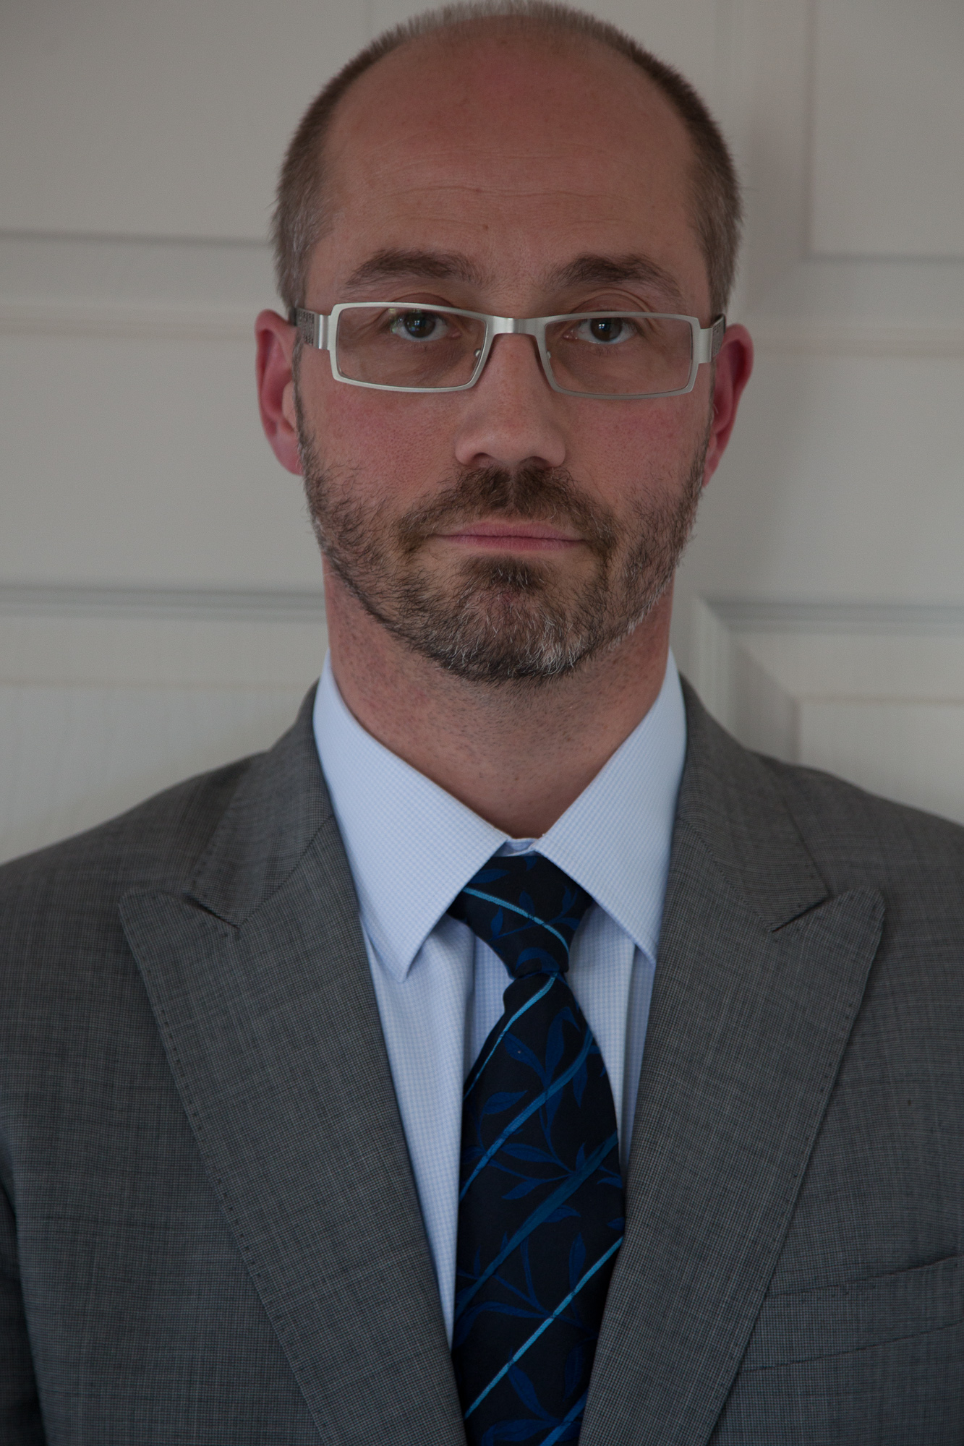
Jean-Pierre-ORAND
Academic / Professional title: |  | DVM
Name of Agency: | Anses-ANMV

Country:
AT BE BG CY CZ DE DK EE EL ES FI FR HU IE IS
IT LI LT LU LV MT NL NO PL PT RO SE SI SK UK

Contact details:
Address: La Haute Marche – Javené -BP 90203 - 35302 FOUGERES - FRANCE
Telephone: 33299947871 Mobile: 33613641322 Fax: 33299947899
E-mail: jean-pierre.orand@anses.fr

Years within the agency: | 2

Education (Institution, area/field pf expertise, country, date) (max. 300 characters)::
1991 : Degree in Veterinary Medicine

Professional experience
(Institution/company, country, position, date. Please provide only information on your current and last 2 jobs). (max. 400 characters):
French Ministry of agriculture : 17 years in the fields of food hygiene, veterinary medicinal products, animal by-products, international trade and foreign affairs. Dr Orand has negotiated several cooperation protocols, put in place twinning with third countries and was the official delegate for France at the World Trade Organization (WTO) for the SPS agreement

Specialisation
Please provide details (max. 300 characters):
1997 : specialization in veterinary pharmacy : good manufacturing practice (GMP), regulations
2000 : specialization in veterinary pharmacy : good laboratory practice (GLP)
2011 : law

Member of any HMA Working Group: | ESS, Task Force improvement of vet legislation (chair) | Information updated on:  25 January 2012

