Country Information
1. Country identification and size of population | AT BE BG CY CZ DE DK EE EL ES  FI FR HU IE IS IT LI LT LU LV  MT NL NO PL PT RO SE SI SK UK  Population size: 4 500 000
Agency Information
2. Agency title and contact details | Name: Irish Medicines Board  Address: Kevin O’Malley House, Earlsfort Centre, Earlsfort Terrace, Dublin 2, Ireland.  Phone: 003031 6764971 Fax: 003531 6764977  E-mail: imb@imb.ie
3. Head of Agency contact details | Please fill CV below on page 4.
4. Regular Representative at HMA Meetings | Please fill CV below on page 5 (if needed).
5. Contact Person for HMA Issues | Name: Pat O’Mahony  Phone: 003531 6343453 Mobile: 00353 87 2908626 Fax: 003531 6344072  E-mail: pat.omahony@imb.ie
6. Type of agency / entity | Independent body  General Directorate. Please specify which Ministry:  Other, please specify:
7. Date of establishment of the Agency | Date: 1995  Please provide any complementary information you may consider relevant:
8. Areas of competence

Human medicinal products
Veterinary medicinal products
Medical Devices
Cosmetics
Others
(please specify): Blood, Tissues and Cells

Information updated on:
April 2008
9. Responsibilities | Human |  |  |  |  |  | Veterinary |  |  |  | Medical Devices | Cosmetics
9. Responsibilities | Pharmacological (incl. chemical and biological/biotech) | Immunological | Homeopathic | Blood products | Herbals | Advanced therapies | Pharmacological | Immunological | Homeopathic | Blood products | Medical Devices | Cosmetics
Authorisation / registration
Clinical Trials / Investigation
Pharmacovigilance / Vigilance / Surveillance
Inspection /
Compliance
Quality Control
Batch release
Pricing
Health Technology Assessment (HTA) / Reimbursement
Regulatory and scientific advice
Information to patients
Information to healthcare professionals
Advertising control
Residues monitoring
Designation and supervision of Notified Bodies
Other (please specify)

Information updated on:

Human Resources
10. Total Number of Employees:250 Full Time: 230 Part-Time: 20 Full-Time equivalence: 240
Outsourced activities:
11. Identification of Internal Experts | Total Number: 145
11. Identification of Internal Experts | Areas of Expertise / Number of Experts
11. Identification of Internal Experts | Quality 30 Pre-clinical 10 Clinical 15  Species Inspections 25 Ecotoxicity  Residues Pharmacovigilance 15  Others Please specify which: 50 workflow, licencing, post l
12. Identification of External Experts (including outsource) | Total Number: 65
12. Identification of External Experts (including outsource) | Areas of Expertise / Number of Experts
12. Identification of External Experts (including outsource) | Quality Pre-clinical Clinical  Species Inspections Ecotoxicity  Residues Pharmacovigilance  Others Please specify which: All
Funding
13. Funding | Budget (state budget) % of budget: 20  Fees (Industry fees/taxes) % of budget: 80  Other Please specify which:
14. Total of expenses (Euros) | 2006: 23m | 2007: 24m
15. Total of revenues (Euros) | 2006: 24m | 2007: 25m
Activities
16. Mission of the organisation (max. 200 characters):
To protect and enhance public and animal health through the regulation of medicines, medical devices and health care products

17. Complementary information | In the case you may consider it useful, please provide complementary information which could clarify any of the issues mentioned above or any specific understanding of your agency on any specific issue or activity (max 200 characters):

Name of the person responsible for completing this questionnaire: | Pat O'Mahony | Information updated on:  April 2008
Head of Agency
Curriculum Vitae

Name of Head of Agency: |  |  |  | 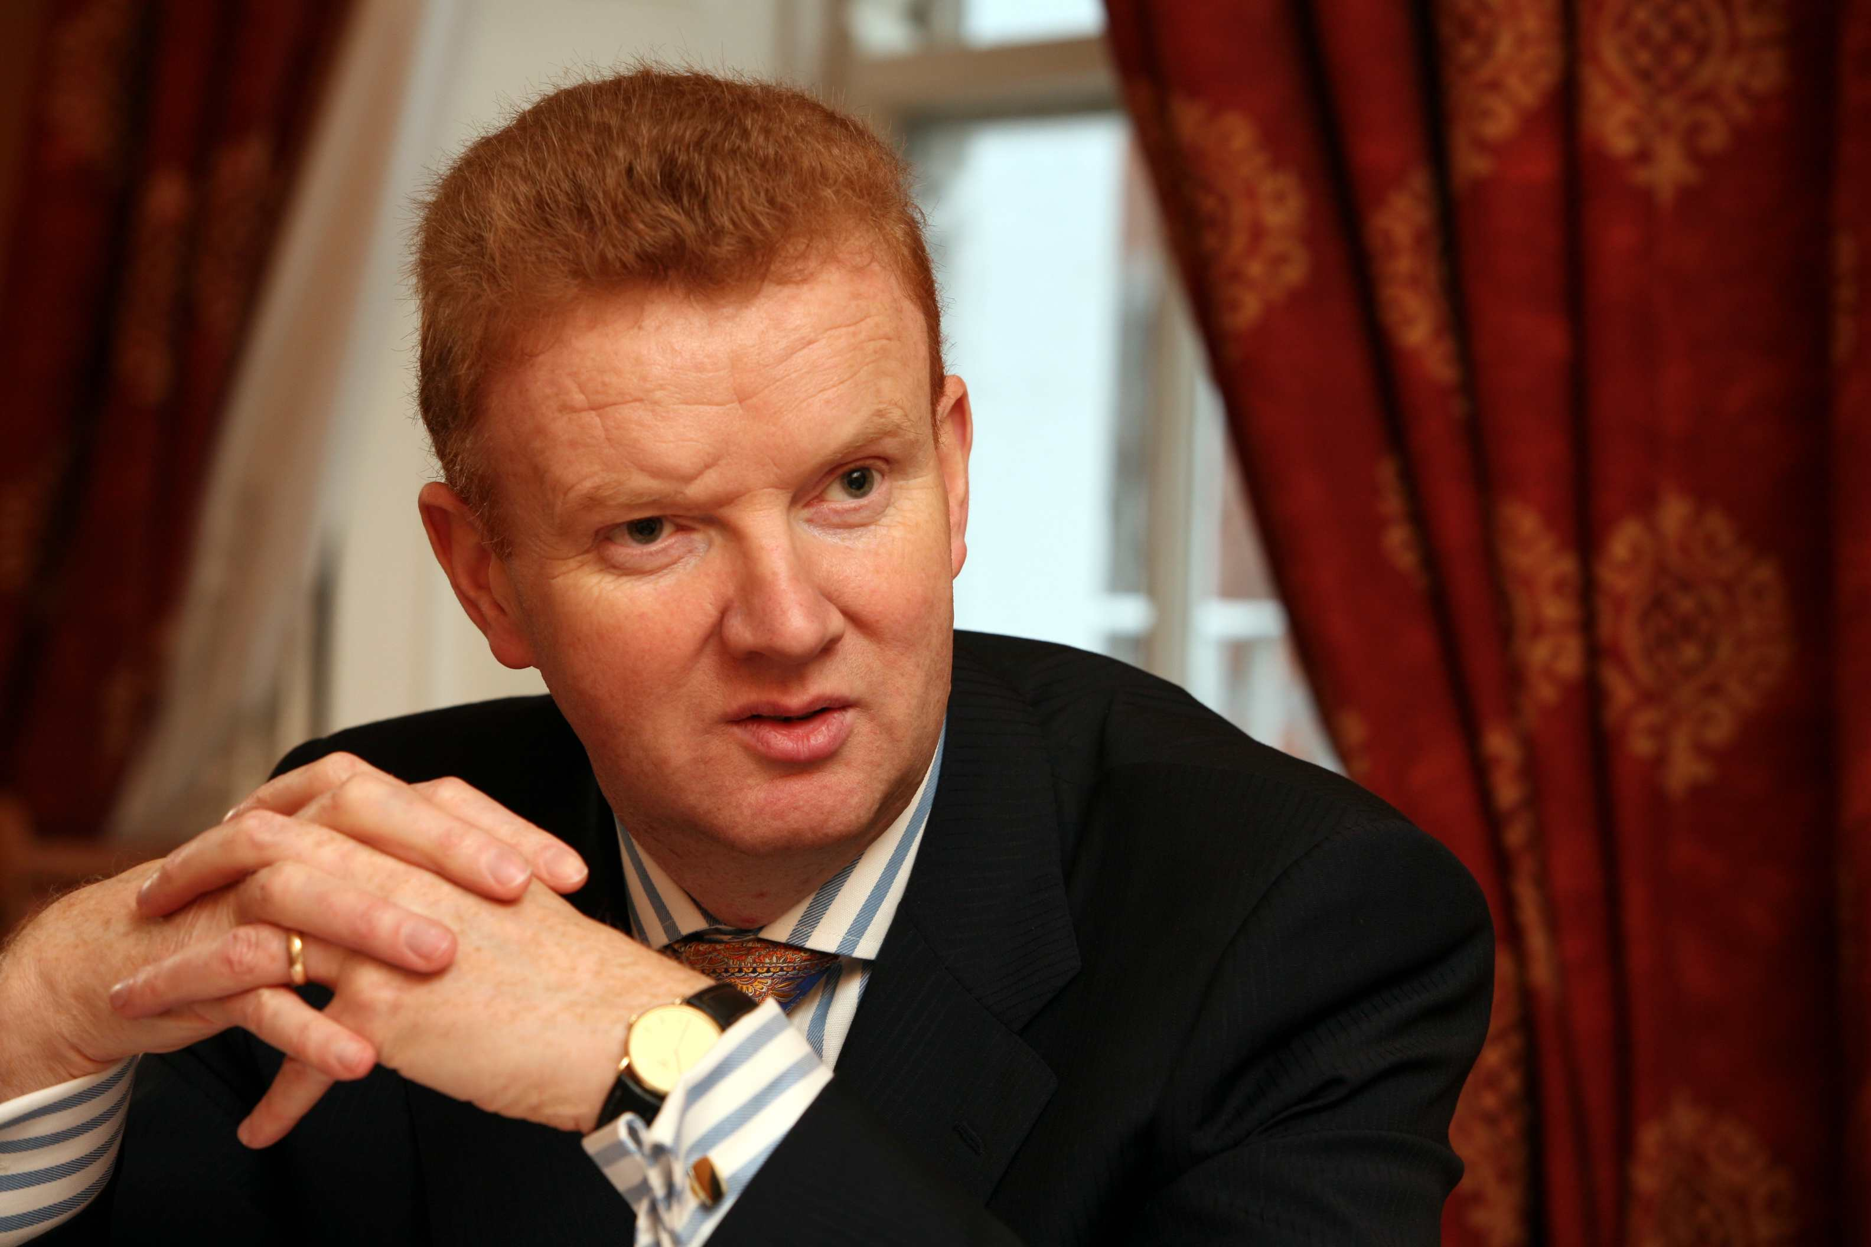
Pat O'Mahony
Academic / Professional title: |  | Mr.
Name of Agency: | Irish Medicines Board

Country:
AT BE BG CY CZ DE DK EE EL ES FI FR HU IE IS
IT LI LT LU LV MT NL NO PL PT RO SE SI SK UK

Contact details:
Address: Irish Medicines Board, Kevin O'Malley House, Earlsfort Centre, Earlsfort Terrace, Dublin 2, Ireland.
Telephone: 003531634345 Mobile: 003538729086 Fax: 003531634407
E-mail: pat.omahony@imb.ie

Years within the agency: | 6

Education (Institution, area/field pf expertise, country, date) (max. 300 characters)::
University College Dublin, Ireland.
1979 - Batchelor of Veterinary Medicine(MVB), 1987 - Master of Veterinary Medicine9MVM), 2001 - Masters in Business Administration(MBA)

Professional experience
(Institution/company, country, position, date. Please provide only information on your current and last 2 jobs). (max. 400 characters):
Now 6 years as CE of IMB.
Previously Director of Food Safety Agency
Now Board member of Food Safety Agency and Irish National Accreditation Board

Specialisation
Please provide details (max. 300 characters):

Member of any HMA Working Group: | BEMA | Information updated on:

