Country Information
1. Country identification and size of population | AT BE BG CY CZ DE DK EE EL ES  FI FR HU IE IS IT LI LT LU LV  MT NL NO PL PT RO SE SI SK UK  Population size: 22,000,000
Agency Information
2. Agency title and contact details | Name: National Medicines Agency  Address: 48, Av. Sanatescu Street, 011478, Bucharest, Romania  Phone: +40213161079 Fax: 40213163497  E-mail: magdalena.badulescu@anm.ro
3. Head of Agency contact details | Please fill CV below on page 4.
4. Regular Representative at HMA Meetings | Please fill CV below on page 5 (if needed).
5. Contact Person for HMA Issues | Name: Rodica Badescu  Phone: +40213161079 Mobile: +40744375650 Fax: 40213163497  E-mail: rodica.badescu@anm.ro
6. Type of agency / entity | Independent body  General Directorate. Please specify which Ministry:  Other, please specify:
7. Date of establishment of the Agency | Date: 01.01.1999  Please provide any complementary information you may consider relevant:  The NMA has been established through reorganisation of the former State Institute for Drug Control and Pharmaceutical Research created in 1956.
8. Areas of competence

Human medicinal products
Veterinary medicinal products
Medical Devices
Cosmetics
Others
(please specify):

Information updated on:
06.05.2008
9. Responsibilities | Human |  |  |  |  |  | Veterinary |  |  |  | Medical Devices | Cosmetics
9. Responsibilities | Pharmacological (incl. chemical and biological/biotech) | Immunological | Homeopathic | Blood products | Herbals | Advanced therapies | Pharmacological | Immunological | Homeopathic | Blood products | Medical Devices | Cosmetics
Authorisation / registration
Clinical Trials / Investigation
Pharmacovigilance / Vigilance / Surveillance
Inspection /
Compliance
Quality Control
Batch release
Pricing
Health Technology Assessment (HTA) / Reimbursement
Regulatory and scientific advice
Information to patients
Information to healthcare professionals
Advertising control
Residues monitoring
Designation and supervision of Notified Bodies
Other (please specify)

Information updated on:
06.05.2008
Human Resources
10. Total Number of Employees:342 Full Time: 324 Part-Time: 12 Full-Time equivalence: 336
Outsourced activities:-
11. Identification of Internal Experts | Total Number: 103
11. Identification of Internal Experts | Areas of Expertise / Number of Experts
11. Identification of Internal Experts | Quality 38* Pre-clinical 6 Clinical 16  Species Inspections 25 Ecotoxicity  Residues Pharmacovigilance 3  Others 15 Please specify which: procedures management, European affairs, pharmacopoeia  * Of the total number of 38 quality assessors, 5 are biological product assessors, who perform both quality and biological product efficacy and safety; these have only been mentioned once, as quality assessors
12. Identification of External Experts (including outsource) | Total Number: 34 *
12. Identification of External Experts (including outsource) | Areas of Expertise / Number of Experts
12. Identification of External Experts (including outsource) | Quality 4 Pre-clinical Clinical 26  Species Inspections Ecotoxicity  Residues Pharmacovigilance  Others Please specify which:  *Of the above mentioned, only 7 are currently actually active experts.
Funding
13. Funding | Budget (state budget) % of budget:  Fees (Industry fees/taxes) % of budget: 100%  Other Please specify which:
14. Total of expenses (Euros) | 2006: 3,633,077.00 | 2007: 4,087,549.00
15. Total of revenues (Euros) | 2006: 5,559,885.00 | 2007: 7,617,585.00
Activities
16. Mission of the organisation (max. 200 characters):
It is the Mission of the NMA to contribute to the protection and promotion of public health through its specific means

17. Complementary information | In the case you may consider it useful, please provide complementary information which could clarify any of the issues mentioned above or any specific understanding of your agency on any specific issue or activity (max 200 characters):

Name of the person responsible for completing this questionnaire: | Rodica Badescu | Information updated on:  06.05.2008
Head of Agency
Curriculum Vitae

Name of Head of Agency: |  |  |  | 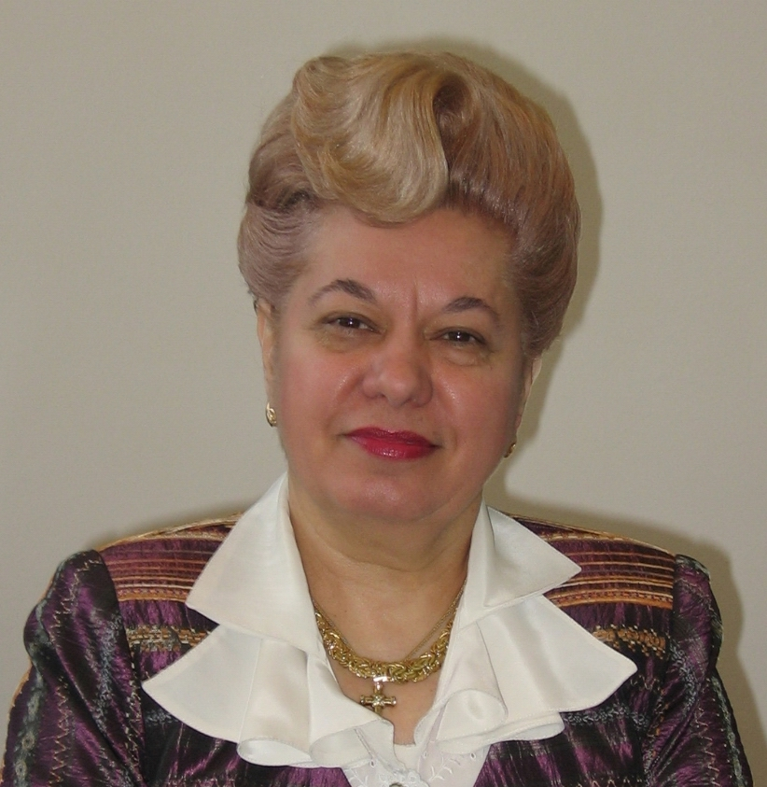
Magdalena Badulescu
Academic / Professional title: |  | Senior Pharmacist
Name of Agency: | National Medicines Agency

Country:
AT BE BG CY CZ DE DK EE EL ES FI FR HU IE IS
IT LI LT LU LV MT NL NO PL PT RO SE SI SK UK

Contact details:
Address: 48, Av. Sanatescu Street, 011478, Bucharest, Romania
Telephone: +40213161079 Mobile: +40744654829 Fax: +40213163497
E-mail: magdalena.badulescu@anm.ro

Years within the agency: | 6

Education (Institution, area/field pf expertise, country, date) (max. 300 characters)::
Faculty of Pharmacy, Bucharest, Romania, graduated in 1972, expertise in regulatory affaires, European affairs, pharmaceutical inspection, quality management,

Professional experience
(Institution/company, country, position, date. Please provide only information on your current and last 2 jobs). (max. 400 characters):
-National Medicines Agency, Romania, President, 01.10.2002 to present;
-Ministry of Health, Romania, Minister of Health Counsellor on pharmaceutical issues: 2000-2004
- Head of the Pharmaceutical Service of the National Health Insurance House : 1999

Specialisation
Please provide details (max. 300 characters):
Doctoral candidate in toxicology at the Faculty of Pharmacy in Bucharest

Member of any HMA Working Group: |  | Information updated on:  06.05.2008

Regular Representative at HMA Meetings
Curriculum Vitae

Name of the regular representative at HMA meetings: |  |  |  | 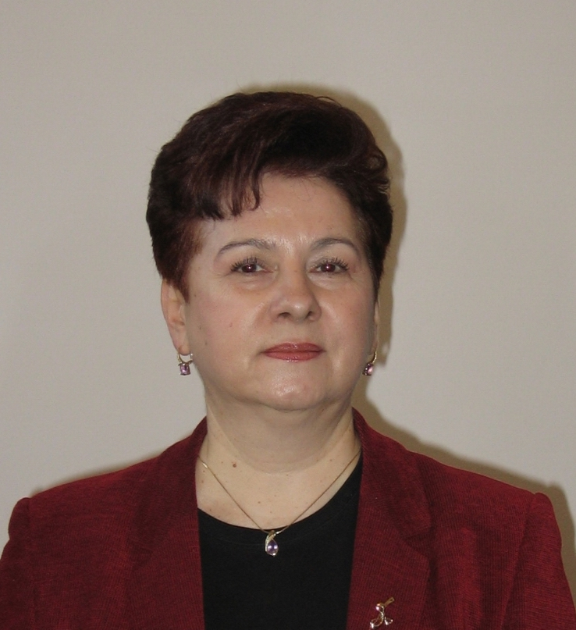
Rodica Badescu
Academic / Professional title: |  | Senior Pharm. MSc
Name of Agency: | National Medicines Agency

Country:
AT BE BG CY CZ DE DK EE EL ES FI FR HU IE IS
IT LI LT LU LV MT NL NO PL PT RO SE SI SK UK

Contact details:
Address: 48, Av. Sanatescu Street, 011478, Bucharest, Romania
Telephone: +40213161079 Mobile: +744375650 Fax: +40213163497
E-mail: rodica.badescu@anm.ro

Years within the agency: | 32

Education (Institution, area/field pf expertise, country, date) (max. 300 characters)::
Faculty of Pharmacy, Bucharest, Romania, graduated in 1976, expertise in regulatory affaires, European affairs, pharmacovigilance, quality management, quality control

Professional experience
(Institution/company, country, position, date. Please provide only information on your current and last 2 jobs). (max. 400 characters):
-National Medicines Agency, Romania, Vice-president, 01.04.2003 to present;
- Head of the NMA Quality Assurance Department: 2002
- Head of the NMA Evaluation-Authorisation Department:2000-2002

Specialisation
Please provide details (max. 300 characters):
Master degree in European Affairs since 2007;

Member of any HMA Working Group: |  | Information updated on:  06.05.2008

