<Date>
<Company Reference>

To: <The address of the preferred reference authority>

Subject: Letter of intent (LoI) for the submission of a worksharing procedure to the CMDv according to Article 65 of Regulation (EU) No 2019/6

Worksharing Applicant details:

Name
Address
Contact person details
(i.e. name, address, email address, phone number).

Application details
This letter of intent (LoI )for the submission of a variation requiring assessment <group of variations> following a worksharing procedure concerns the following medicinal products:

- List of marketing authorisations concerned:
MR/DC authorised products:
Product (trade name) | Active substance | Member State | MA holder name | MRP/DCP no. & MA number

Nationally authorised products :
Product (trade name) | Active substance | Member State | MA holder name | MA number

- Description of the changes
The following variation(s) are intended to be part of the worksharing procedure:
Number as in the classification guidance | Title of variation as in the classification guidance

<Include here a detailed description and background of the changes listed and a justification for the proposed classifications>
<See attachment>*<if grouping is proposed, a justification should be provided>

< The table with current and proposed situation may be added for clarification>
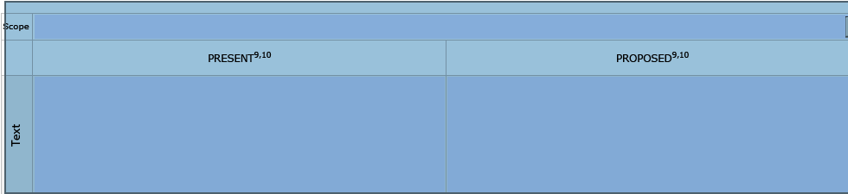
<See attachment>*
(* If the lists are very long they can be submitted as separate attachments to the Letter of intent)
<If agreed by RA/CMSs the following sentence could be included in the final Letter of intent for complex worksharing procedures: >
<The final variation classifications will be (discussed and) agreed between the RMS and CMSs during the validation period>

- Preferred Reference Authority

Justification as to why the MAH believes that a worksharing procedure is applicable.
- Intended submission date

- Explanation that all MAs concerned belong to the same holder

- If applicable, details of submission/approval/rejection of the same variation(s) in any Member State(s)

- If applicable, details of any MAs (MR/DC or purely-national) that have been excluded from the proposed worksharing procedure, with reasons.
< This will prevent delays in the consideration of the letter of intent, which can occur when Member States that have the product(s) authorised are unclear why they have not been included in a particular worksharing procedure >

<Signature>

Please provide both the MRP/DCP number and the national authorisation to aid identification

